NAME:

Login name:

Computer Science 461
Midterm Exam
March 14, 2007
1:30-2:50pm

This test has seven (7) questions. Put your name on every page, and write out and sign the Honor Code pledge before turning in the test.

Please look through all of the questions at the beginning to help in pacing yourself for the exam. The exam has 100 points and lasts for 80 minutes, so the number of minutes spent per question should be less than its point value. You should spend no more than 10-12 minutes per question.

``I pledge my honor that I have not violated the Honor Code during this examination.''

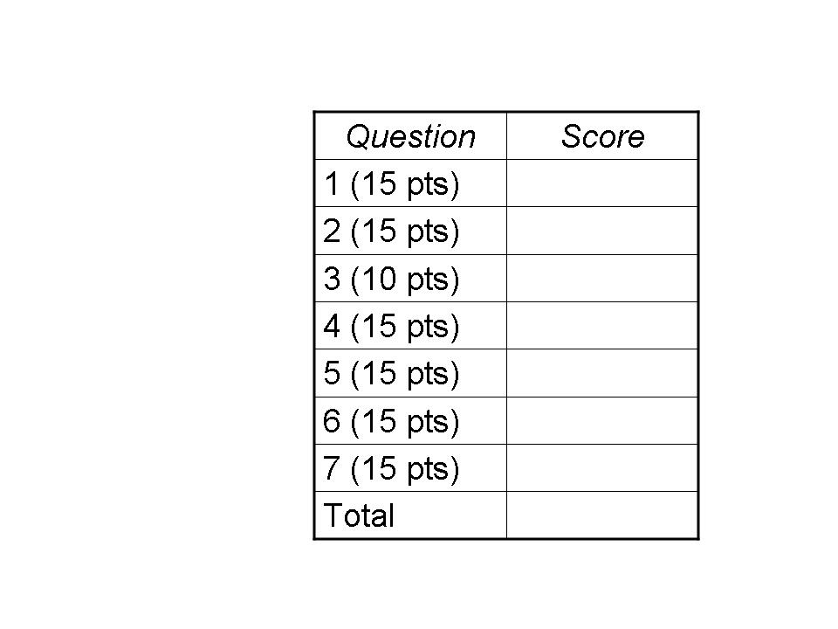

QUESTION 1: Internet Versus Station Wagon (15 POINTS)

A famous maxim, sometimes attributed to Dennis Ritchie, says “Never underestimate the bandwidth of a station wagon full of tapes.” Suppose you need to deliver a large file between two computers that are 200 km apart and connected by a direct link. This question analyzes when it is faster to drive the data between the two locations, rather than transmit the data?

(1a) Suppose the station wagon drives 100 km/hour and the link has a bandwidth of 800,000 bits/second. And, suppose for simplicity that the data transfer can fully consume the link bandwidth, with no additional overhead (e.g., for headers or the TCP sawtooth). At what file size (in bytes) does the station-wagon solution start delivering the data faster? Show your work.

(1b) Suppose the sender transmits the data as packets with a 20-byte IP header, and 20-byte TCP header, and a maximum segment size of 512 bytes. How much more time (as a fraction) would the data transfer take on the link? (Ignore TCP congestion control and the link-layer header.)

(1c) Suppose that, like the path traversed by the car, the link is 200 km long. The speed of electricity in a copper cable is 200,000,000 meters/second. How big does the receive window need to be to avoid becoming the main constraint on the transfer rate? (Ignore the effects of header sizes, TCP congestion control, and packet loss, and assume that the receiver immediately sends an ACK packet after receiving each data packet and that there is no congestion.)

QUESTION 2: Sockets (15 POINTS)

(2a) Suppose application A is using a stream socket to transfer data to application B on a remote host. Suppose application A writes data into the socket buffer ten times. Why might the underlying TCP implementation transmit more than ten data packets (not including retransmissions of lost packets, or control packets like SYN, ACK, or FIN)?

(2b) Why might the TCP implementation transmit all of the data in fewer than ten data packets?

(2c) Why can application A safely perform a close() on the socket when it is done writing the data, even if application B has not yet received all of the data?

(2d) List two possible explanations for why host A would need to retransmit the SYN packet as part of establishing the TCP connection with B.

(2e) Since a datagram socket (i.e., a UDP socket) does not require establishing a connection, why is a port number necessary?

QUESTION 3: Demultiplexing (10 points)

(3a) Suppose an organization runs a Network Address Translator. When a packet arrives from the external Internet, what field(s) determine which internal IP address to use as the destination address for the packet? What other fields in the IP and TCP/UDP header does the NAT change?

(3b) Suppose the NAT then places the IP packet in an Ethernet frame to send to the receiving host. How does the NAT know what destination MAC address to use?

(3c) Once the Ethernet frame reaches the destination host, how does the host know what network-layer protocol (e.g., IP, IPX, Appletalk) should be used to parse the payload?

(3d) How does the operating system know if the packet is a UDP packet or a TCP packet?

(3e) How does the operating system know which process (and which socket) should receive the packet?

QUESTION 4: Cheaters Sometimes Win (15 points)

Many of the protocols underlying the Internet rely on end hosts to faithfully implement the protocols correctly, for the greater good. This question explores what happens when they don’t.

(4a) List one motivation for a host to send an IP packet with the wrong source IP address. List two ways that this can adversely affect the legitimate owner of that IP address.

(4b) Consider a multi-access Ethernet where one host has an adapter that does not back off after detecting a collision. Describe how this would affect the communication performance for the other hosts.

(4c) Consider a TCP implementation that does not reduce its sending rate in response to packet loss. Describe how this would affect the other TCP traffic sharing the congested link. Also, explain whether/how this non-compliant behavior might hurt the performance of the offending TCP connection.

(4d) Many Web browsers open several TCP connections in parallel when downloading multiple embedded images. How does this affect the other TCP traffic sharing the same congested link? When no other traffic traverses the links, is using multiple parallel connections still beneficial to the user? Why or why not?

(4e) Some implementations of ARP process an ARP reply (by updating the local ARP cache) even when there are no ARP requests pending. Suppose a rogue computer sends an unsolicited ARP reply message, with its own MAC address and the IP address of the LAN gateway router, to another host on the LAN. What will happen when this host (i.e., the host who believed the bogus ARP reply) transmits an IP packet destined to an external Internet address?

QUESTION 5: Home-Network “Box” (15 points)

Consider a home network with multiple hosts plugged in (via Ethernet cables) to a Box that has a link directly to a residential broadband provider (e.g., via a DSL line). Suppose the broadband provider assigns a single public address to each home. This question explores the many functions that the Box implements.

(5a) The Box may, at different times, act as both a DHCP client and a DHCP server. Why would it act as a client? Why would it act as a server?

(5b) The Box serves as a gateway router for the hosts in the home network. How do the hosts in the home network learn the IP address of the gateway? Is this the same address as the single public address the provider allocated to the home? Why or why not?

(5c) Suppose a host in the home network sends a TCP SYN packet to a Web server in the external Internet. Explain the role of ARP and NAT in getting the first IP packet from the host through the home network and out the connection to the Internet.

(5d) Some Web sites on the Internet allow a home user to determine the public IP address the broadband provider has assigned to the home. Why might it be hard for the end user to determine the IP address directly? How does the external Web site know?

QUESTION 6: Internet Principles (15 POINTS)

(6a) List one advantage and one disadvantage of using soft state over hard state. Give two examples of the use of soft state from the protocols covered in class.

(6b) List one advantage and one disadvantage of using a text-based header (as in HTTP) instead of a binary format. Why does IP use a binary format?

(6c) IP allows variable-sized packets. List one advantage and one disadvantage of forcing all packets to be the same size.

(6d) List one advantage and one disadvantage of classless interdomain routing (CIDR) over the earlier use of classful routing.

(6e) List one disadvantage of having a TCP retransmission timeout (RTO) that is too large. List one disadvantage of having an RTO this is too small.

QUESTION 7: Decentralized Control (15 points)

(7a) Why does a TCP sender decrease its sending rate (on a packet loss) more aggressively than it increases the sending rate (after successful packet delivery)?

(7b) The way a TCP sender reacts to packet loss depends on how the loss was detected. What are the two scenarios? How does the TCP sender adapt its rate in each case? Why are these two cases handled differently?

(7c) Give two reasons why a local DNS server is not configured with the IP addresses of the top-level domain servers (e.g., for “.com” or “.org”). How does the local DNS server learn the addresses of the top-level domain servers?

(7d) List two reasons for the hierarchical allocation of IP address blocks in the Internet, from one institution to another.

(7e) MAC addresses only have significance within the context of a local-area network. So, why are MAC addresses globally unique?

