NAME:

Login name:

Computer Science 461
Midterm Exam
March 14, 2007
1:30-2:50pm

This test has seven (7) questions. Put your name on every page, and write out and sign the Honor Code pledge before turning in the test.

Please look through all of the questions at the beginning to help in pacing yourself for the exam. The exam has 100 points and lasts for 80 minutes, so the number of minutes spent per question should be less than its point value. You should spend no more than 10-12 minutes per question.

``I pledge my honor that I have not violated the Honor Code during this examination.''

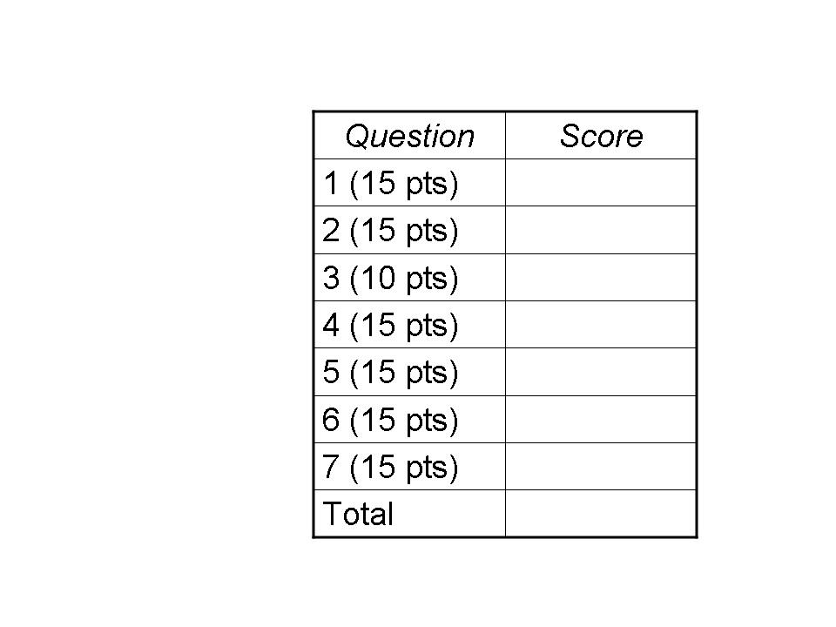

QUESTION 1: Internet Versus Station Wagon (15 POINTS)

A famous maxim, sometimes attributed to Dennis Ritchie, says “Never underestimate the bandwidth of a station wagon full of tapes.” Suppose you need to deliver a large file between two computers that are 200 km apart and connected by a direct link. This question analyzes when it is faster to drive the data between the two locations, rather than transmit the data?

(1a) Suppose the station wagon drives 100 km/hour and the link has a bandwidth of 800,000 bits/second. And, suppose for simplicity that the data transfer can fully consume the link bandwidth, with no additional overhead (e.g., for headers or the TCP sawtooth). At what file size (in bytes) does the station-wagon solution start delivering the data faster? Show your work.

By car, travel time is 2 hours (i.e., 200 km * 1hr/100km). During two hours, the link could transfer 800,000 bits/sec * 60 sec/min * 60 min/hour * 2hr * 1byte/8bits for 720,000,000 bytes.

(1b) Suppose the sender transmits the data as packets with a 20-byte IP header, and 20-byte TCP header, and a maximum segment size of 512 bytes. How much more time (as a fraction) would the data transfer take on the link? (Ignore TCP congestion control and the link-layer header.)

An MSS of 512 bytes and two 20-byte headers leads to a packet size of 552 bytes. So, only 512/552 of the bandwidth is used to transmit the actual data, so the transfer takes 552/512 of the time, or 40/512 times longer. This reduces to a factor of 5/64 longer time.

(1c) Suppose that, like the path traversed by the car, the link is 200 km long. The speed of electricity in a copper cable is 200,000,000 meters/second. How big does the receive window need to be to avoid becoming the main constraint on the transfer rate? (Ignore the effects of header sizes, TCP congestion control, and packet loss, and assume that the receiver immediately sends an ACK packet after receiving each data packet and that there is no congestion.)

The receive window needs to be large enough to accommodate a round-trip time of data. The one-way delay is 1sec/200,000km * 200km, or 0.001 seconds (or 1 msec). So, the round-trip time is 0.002 seconds (or 2 msec). Since the link bandwidth is 800,000 bits/sec, the total number of bytes transmitted during a round-trip time is 0.002 sec * 800,000bits/sec * 1byte/8bits, or a grand total of 200 bytes.

QUESTION 2: Sockets (15 POINTS)

(2a) Suppose application A is using a stream socket to transfer data to application B on a remote host. Suppose application A writes data into the socket buffer ten times. Why might the underlying TCP implementation transmit more than ten data packets (not including retransmissions of lost packets, or control packets like SYN, ACK, or FIN)?

If the application writes more than an MSS of data, a single write() call may lead to multiple TCP segments and, hence, multiple packet transmissions.

(2b) Why might the TCP implementation transmit all of the data in fewer than ten data packets?

If the application writes less than an MSS of data, the data from multiple write() calls may be combined into a single TCP segment and, hence, a single packet transmission. This is especially true in applications like Telnet, when Nagle’s algorithm is used.

(2c) Why can application A safely perform a close() on the socket when it is done writing the data, even if application B has not yet received all of the data?

The TCP implementation (typically in the operating system) buffers the data and continues to (re)transmit the data to the receiver as needed.

(2d) List two possible explanations for why host A would need to retransmit the SYN packet as part of establishing the TCP connection with B.

The SYN packet may have been lost in the network, discarded by the receiver due to a checksum error, or discarded because the receiver’s listen queue is full. Or, the SYN-ACK packet may have been lost. Or, the RTO might have been too small (e.g., for a very long-haul link to Mars).

(2e) Since a datagram socket (i.e., a UDP socket) does not require establishing a connection, why is a port number necessary?

For demultiplexing the packet to the correct receiving socket.

QUESTION 3: Demultiplexing (10 points)

(3a) Suppose an organization runs a Network Address Translator. When a packet arrives from the external Internet, what field(s) determine which internal IP address to use as the destination address for the packet? What other fields in the IP and TCP/UDP header does the NAT change?

When a packet arrives from the external Internet, the NAT box inspects the destination port number (and address, if the NAT has multiple external-facing IP addresses) to identify the receiving host. The NAT changes the destination address and port, as well as the checksum.

(3b) Suppose the NAT then places the IP packet in an Ethernet frame to send to the receiving host. How does the NAT know what destination MAC address to use?

The NAT box checks in its ARP table for the MAC address corresponding to the internal destination address. If no match is found in the ARP table, the NAT box issues an ARP query to learn the associated MAC address.

(3c) Once the Ethernet frame reaches the destination host, how does the host know what network-layer protocol (e.g., IP, IPX, Appletalk) should be used to parse the payload?

The Ethernet frame has a “type” field that identifies the network-layer protocol.

(3d) How does the operating system know if the packet is a UDP packet or a TCP packet?

The IP header has a “protocol” field that identifies the transport-layer protocol.

(3e) How does the operating system know which process (and which socket) should receive the packet?

The protocol field (in the IP header) and the destination port (in the transport-layer header) identify the receiving socket.

QUESTION 4: Cheaters Sometimes Win (15 points)

Many of the protocols underlying the Internet rely on end hosts to faithfully implement the protocols correctly, for the greater good. This question explores what happens when they don’t.

(4a) List one motivation for a host to send an IP packet with the wrong source IP address. List two ways that this can adversely affect the legitimate owner of that IP address.

A host launching a denial-of-service attack may send packets with a “spoofed” source address that corresponds to another host, in order to evade detection. The legitimate owner may be blamed for the attack (and perhaps also blocked from sending legitimate traffic to the victim destination), and may also receive unwanted return traffic (e.g., SYN-ACK or RST packets).

(4b) Consider a multi-access Ethernet where one host has an adapter that does not back off after detecting a collision. Describe how this would affect the communication performance for the other hosts.

When a collision occurs, the other (well-behaved) adapters would back off, while the rogue adapter would continue sending; the well-behaved adapters would not try to send again because the link is already busy. Ultimately, the rogue adapter would have nearly complete control of the link, leaving the other adapters will little or no bandwidth.

(4c) Consider a TCP implementation that does not reduce its sending rate in response to packet loss. Describe how this would affect the other TCP traffic sharing the congested link. Also, explain whether/how this non-compliant behavior might hurt the performance of the offending TCP connection.

By not reducing the sending rate in response to packet loss, the rogue TCP sender would not do its part to reduce congestion, forcing other packets to be dropped. Eventually, well-behaved TCP senders would reduce their sending rates and share whatever bandwidth the rogue sender is not using. This would lead to unfairness. It may also hurt the rogue TCP sender because driving the link beyond its capacity may cause loss of the rogue sender’s packets, requiring retransmisisons.

(4d) Many Web browsers open several TCP connections in parallel when downloading multiple embedded images. How does this affect the other TCP traffic sharing the same congested link? When no other traffic traverses the links, is using multiple parallel connections still beneficial to the user? Why or why not?

The extra TCP connections allow the Web browser to have an unfair share of the bandwidth of the bottleneck link, reducing the throughput of other, well-behaved applications. When no other traffic traverses the link, the multiple connections share bandwidth only with each other. Still, this may be beneficial if the connections are RTT-limited, and because the user likes to see multiple embedded images fill in at the same time; also, the parallel connections collectively get more bandwidth during slow start.

(4e) Some implementations of ARP process an ARP reply (by updating the local ARP cache) even when there are no ARP requests pending. Suppose a rogue computer sends an unsolicited ARP reply message, with its own MAC address and the IP address of the LAN gateway router, to another host on the LAN. What will happen when this host (i.e., the host who believed the bogus ARP reply) transmits an IP packet destined to an external Internet address?

The host would send the packet in an Ethernet frame destined to the MAC address of the rogue machine, which may discard the traffic, or may inspect the contents before directing the packet to the legitimate gateway.

QUESTION 5: Home-Network “Box” (15 points)

Consider a home network with multiple hosts plugged in (via Ethernet cables) to a Box that has a link directly to a residential broadband provider (e.g., via a DSL line). Suppose the broadband provider assigns a single public address to each home. This question explores the many functions that the Box implements.

(5a) The Box may, at different times, act as both a DHCP client and a DHCP server. Why would it act as a client? Why would it act as a server?

The Box acts as a DHCP client to the DSL provider’s DHCP server, to get a public IP address. The Box acts as a DHCP server to allocate private IP addresses to the internal hosts.

(5b) The Box serves as a gateway router for the hosts in the home network. How do the hosts in the home network learn the IP address of the gateway? Is this the same address as the single public address the provider allocated to the home? Why or why not?

The hosts in the home network learn the internal-facing address of the gateway via DHCP. This is not the same as the external-facing address assigned by the ISP. Typically, the ISP assigns an address from its own (public) address block, whereas the internal-facing address lies in the (private) address block used to number devices in the home network.

(5c) Suppose a host in the home network sends a TCP SYN packet to a Web server in the external Internet. Explain the role of ARP and NAT in getting the first IP packet from the host through the home network and out the connection to the Internet.

The host recognizes that the destination IP address of the packet falls outside of the local subnet and, as such, directs the IP packet to the gateway router (i.e., the Box). The host uses ARP to determine the MAC address of the gateway, by consulting its ARP cache or, on a cache miss, issuing an ARP query). Then, the host sends the Ethernet frame to the gateway (i.e., the Box). The Box then maps the source address and source port, using a NAT table, before directing the traffic to the Internet. (The Box may also use ARP to learn the MAC address of the DSL provider’s gateway router.)

(5d) Some Web sites on the Internet allow a home user to determine the public IP address the broadband provider has assigned to the home. Why might it be hard for the end user to determine the IP address directly? How does the external Web site know?

The end host learns the private (internally-facing) address of the NAT box, not the public (externally-facing) address. In contrast, the Web server receives the HTTP request on a TCP connection from the public address of the NAT box and, as such, knows the public address.

QUESTION 6: Internet Principles (15 POINTS)

(6a) List one advantage and one disadvantage of using soft state over hard state. Give two examples of the use of soft state from the protocols covered in class.

Soft state is robust to a device that fails ungracefully and does not relinquish its state. However, soft state wastes resources in repeatedly refreshing state. Examples of soft state include the TTL in DNS caching, the lease time in DHCP, and the caching time for ARP entries and NAT bindings.

(6b) List one advantage and one disadvantage of using a text-based header (as in HTTP) instead of a binary format. Why does IP use a binary format?

A text-based header is easier for human beings to read and debug. Text-based headers are also extensible. However, they are verbose (i.e., waste bandwidth) and harder to parse. IP uses a binary format to limit the bandwidth consumed by the header, and to simplify parsing at the router, which much process packets very quickly (e.g., within a few nanoseconds on high-speed links).

(6c) IP allows variable-sized packets. List one advantage and one disadvantage of forcing all packets to be the same size.

Fixed-sized packets do not need extra header space for a packet-length field, and they are easier to managed (e.g., fixed-sized buffers). However, fixed-sized packets waste bandwidth due to padding when the data is smaller than the packet size.

(6d) List one advantage and one disadvantage of classless interdomain routing (CIDR) over the earlier use of classful routing.

CIDR allows more efficient allocation of the limited address space, by permitting a wide variety of sizes of address blocks. However, CIDR requires routers to perform longest-prefix-match forwarding, which is hard to do quickly.

(6e) List one disadvantage of having a TCP retransmission timeout (RTO) that is too large. List one disadvantage of having an RTO this is too small.

If the RTO is too large, the sender waits too long to retransmit a lost packet, leading to slower data transfers. If the RTO is too short, the sender unnecessarily retransmits packets that were not actually lost, wasting network bandwidth.

QUESTION 7: Decentralized Control (15 points)

(7a) Why does a TCP sender decrease its sending rate (on a packet loss) more aggressively than it increases the sending rate (after successful packet delivery)?

Overshooting the capacity of the path has dire consequences in terms of congestion collapse, whereas undershooting just makes the network a little less efficient than it otherwise would be. The multiplicative decrease algorithm of TCP is crucial to its stability.

(7b) The way a TCP sender reacts to packet loss depends on how the loss was detected. What are the two scenarios? How does the TCP sender adapt its rate in each case? Why are these two cases handled differently?

When loss is detected by a timeout, the sender decreases the sending rate to 1 MSS and repeats slow start, assuming that network congestion is quite serious. When loss is detected by a triple-duplicate ACK, the sender halves the sending rate, assuming that the congestion is not too bad.

(7c) Give two reasons why a local DNS server is not configured with the IP addresses of the top-level domain servers (e.g., for “.com” or “.org”). How does the local DNS server learn the addresses of the top-level domain servers?

The top-level domain servers may change over time, and new top-level domains (such as the country codes in recent years) may be added. The local DNS server is configured only with the addresses of the 13 root servers, and contacts one of these servers to learn the address of the TLD server of interest.

(7d) List two reasons for the hierarchical allocation of IP address blocks in the Internet, from one institution to another.

Hierarchical allocation reduces administrative overhead by allowing regional Internet registries to allocate large blocks to ISPs who, in turn, allocate smaller blocks to their customers. Hierarchical allocation also improves the efficiency of the routing system since, often, these smaller address blocks do not need to be known globally, since the customers are reachable via their providers that own and announce the containing (larger) address block.

(7e) MAC addresses only have significance within the context of a local-area network. So, why are MAC addresses globally unique?

If two devices had the same MAC address, they might sometime reside on the same LAN, leading to mass confusion. (More specifically, the self-learning switches might go back and forth in determining which way to forward frames, so sometimes one device would receive the frames and sometimes the other. Bad scene all around, and very hard to debug.)

